Exeter District Ambulance

Fiscal Year 2024 – 2025

Budget

Community members and District Board of Directors:

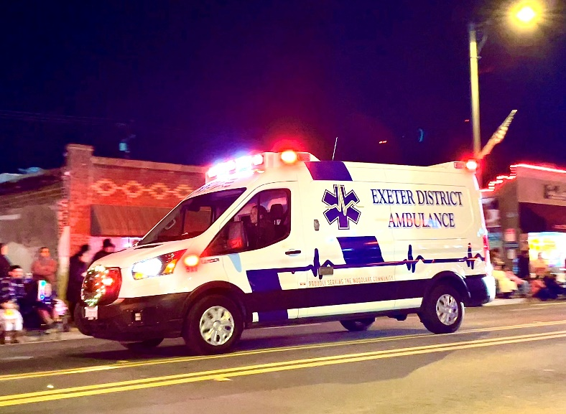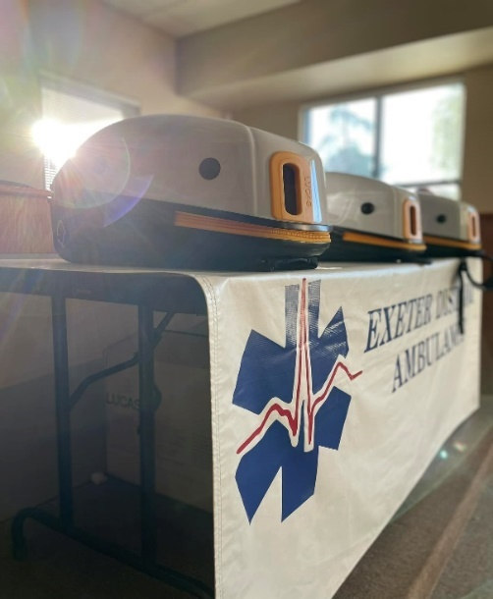It is my pleasure to present to you the Exeter District Ambulance fiscal year 2024-2025 Budget. Exeter District Ambulance, referred to as the “District”, is an independent Special District formed on March 15, 1977 by a majority vote of constituents within the District boundaries in accordance with the California Health and Safety Code Section 32002.3 to provide healthcare services to the residents of the District which includes the City of Exeter and the communities of Lemon Cove, Lindcove and unincorporated county areas in between. Exeter District Ambulance is governed by five elected officials each serving a term of two years. A single District Manager is appointed by the Board of Directors to administer the operations and business of the District. The District proudly serves as the primary ambulance provider for several communities outside of the District boundaries including the Cities of Woodlake and Farmersville by contract with the County of Tulare as well as participates in the Tulare County EMS response plan responding to other communities within Tulare county as the closest available ambulance if needed. The District provides full service Advanced Life Support Ambulances staffed by one Paramedic and one Emergency Medical Technician, as well as Basic Life Support ambulances staffed by two Emergency Medical Technicians, and a field supervisor vehicle staffed by a supervisor or manager. There are 34 dedicated EMT’s and Paramedics that serve the District. The District currently operates two stations to protect the communities we proudly serve. The Exeter station is located at 302 E. Palm St. in the City of Exeter with two Advanced Life Support Ambulances Staffed 7 days a week, 24 hours a day, 365 days a year. The Woodlake station is leased to Exeter District Ambulance by the Woodlake Fire District and is located at 120 N. Magnolia in the City of Woodlake directly behind the Woodlake Fire District station. There are two Advanced Life Support Ambulances that operate from the Woodlake station 7 days a week, 24 hours a day, 365 days a year. Each ambulance is equipped with the base equipment required by Tulare County as well as additional equipment to provide exceptional service to our patients including a Lucas CPR device on every ambulance as well as video laryngoscopes, stair chairs and several other life saving pieces of equipment not routinely carried by other ambulance providers. The District office is located at 302 E. Palm St. in the City of Exeter. The office hours for the District office are Monday, Tuesday, Thursday, and Friday from 0900 (9:00 AM) to 1400 (2:00 PM). The District office is closed to the public on Wednesdays. The District is committed to full transparency with the public regarding its operations and finances. Members of the public are encouraged to visit the office during normal business hours if they have questions or concerns. Additional resources and information about the District can be obtained on the Districts website at [www.edaems.com](http://www.edaems.com).

The budget and its development are the responsibility of the District Manager. Once completed by the District Manager, no later than the end of June of a given year, the budget is then presented to the District Board of Directors for approval. The development of the budget is done utilizing financial reports such as audited District profit and loss statements from the previous fiscal year, financial predictions such as the Department of Transportation economic forecast for Tulare County, call volume data for the previous calendar and fiscal years, and past budgets. This budget and its contents were put together to the best of my knowledge and experience and I am confident it will serve and provide for the District not only the 2024-2025 fiscal year but also the future of the District through capital improvement purchases and established unassigned or reserve funds.

Looking at the Fiscal Year 2023 – 2024 budget compared to actual there were several account lines where the expense was higher than what was budgeted. There was an overall 31.12% increase in the total expense compared to what was budgeted. Most of these increased expenses can be attributed to several factors that were in fact exceptionally beneficial to the District. These factors include a 3.62% increase in the overall call volume for the 2023 calendar year compared to the 2022 calendar year that has continued each month after into the 2024 calendar year compared to 2023. This increase in call volume resulted in increased dispatching fees for services past what was budgeted. Concomitantly with the increased call volume the District also saw a 1.87% increase in patients transported which resulted in increased patient care reports (PCR) and a higher billing fees for service to process those PCR then was budgeted.

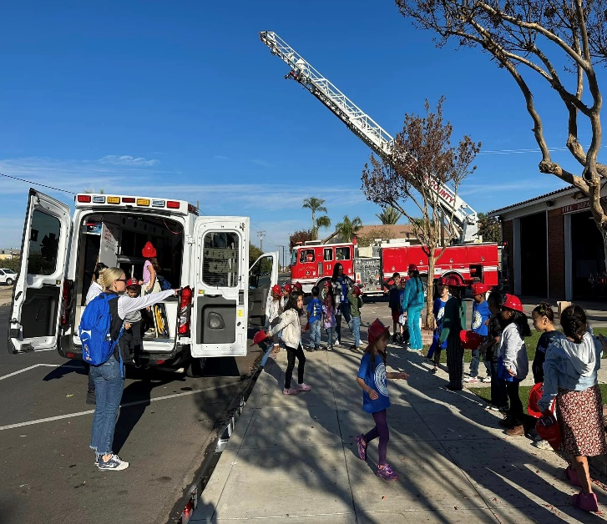To accommodate the increase in call volume a fourth ambulance was added in December, of 2023. To control the personnel cost only two full-time employees were hired to staff the fourth ambulance with the remaining positions for this fourth ambulance to be filled with per diem employees. However, even with this control in place, the personnel cost was still 35.8% higher than budgeted. While inflation has dropped in 2023 compared to its peak in 2021, it continues to create cost increases in items such as medical supplies, which saw a 104.89% increase from what was budgeted. While inflation is the biggest reason for the increase in the medical supply expense, increased call volume and transports has also lead to increased use.

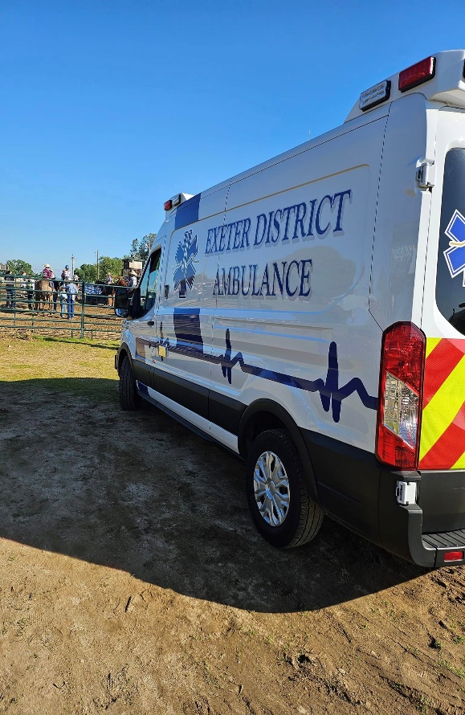Despite the overall increase in expenses discussed above the District had a 70.29% increase in gross profit compared to what was budgeted in the previous fiscal year with a 992.84% increase in net profit from what was budgeted in the previous fiscal year. These increases can be attributed to several factors including the increased call volume, cost-saving capital improvement purchases implemented over the past 18 months by the District Manager and the Board of Directors, and a change in the District State of California Reimbursement program. Effective January 1, 2023 in accordance with Assembly Bill (AB) 1705 (Chapter 544, Statutes of 2019), the Department of Health Care Services (DHCS) developed the Public Provider Ground Emergency Medical Transport (PPGEMT) Program to provide increased reimbursements, by application of an add-on increase to ground emergency medical transports (GEMT) provided by eligible non-contracted public GEMT providers. This resulted in an 863.3% increase in refunds per transport. With the passage of this bill the District will no longer be assessed the Quality Assurance Fee (QAF) that cost the District tens of thousands of Dollars a year. While this change in state healthcare ground transport reimbursement program yielded dramatic increases in revenue, the capitol improvement purchases and plans implemented by the District Manager and the Board of Directors also plaid a key role in the Districts current position. On April 26, 2024, the Board of Directors approved the purchase of two new ambulances to replace aging ambulances that were creating excessive maintenance expenses for the District. These new ambulances were received and placed in service on July 2, 2023. A third new ambulance was approved by the Board of Directors on December 12, 2023. This third ambulance was received and placed into service in January of 2024. With these new ambulances in place and less maintenance expense there was a 46.61% decrease in vehicle maintenance expense this past fiscal year as compared to the 2022-2023 Fiscal year budget. The new ambulances purchased not only provide better service to our community and decreased maintenance expense but also more efficient operation that has led to a 15.07% decrease in fuel cost at a time when fuel prices are at an all-time high.

When creating this current 2024-2025 fiscal year budget, call volume and projected call volume was an important consideration. Though Exeter District Ambulance is a special District as explained above and does collect tax revenue, the tax revenue the District collects accounts for only 10.58% of the Districts revenue. The remaining 89.42% of the revenue for the District comes directly from medical billing for services rendered.

The District relies heavily on transport revenue to continue and expand operations. Call volume has increased each month compared to the same month of the previous year since June 2023 when the District assumed full operations for the City of Woodlake which was previously a shared responsibility with American Ambulance of Visalia. The question was whether or not June 2024 would also be an increase as it marked the 1 year anniversary of the District being the soul provider for the City of Woodlake. Incredibly June 2024 yielded a 9.67% increase in patients transported. With call volume consistently showing increases as well as increasing property values and tax revenue, I believe the revenue generated in fiscal year 2023-2024 to be a stable number to use when calculating available general fund expenses for the fiscal year 2024-2025.

11.07% of the total budgeted gross profit or roughly 60 days of operational expense has been set aside as unassigned/reserve funds. These unassigned finds will improve the Districts ability to plan for future or unforeseen expenses. Several of the account lines are budgeted for less than was recorded for the previous fiscal year. This will be feasible with changes that have been made in vendors to ensure that the District is fiscally responsible and efficient. Lastly, I would like to draw your attention to account line number 6270-fines and assessments which shows a 30.81% increase from what was budgeted last fiscal year and a current budgeted decrease of 97.49%. The reason for the increase is due to quarterly ambulance fee (QAF) payments made when the District was part of the Ground Emergency Medical Service (GEMT) Program for fiscal year 2022-2023. As of January 2024, all government ambulance providers were moved to the Public Provider Ground Emergency Medical Transportation (PPGEMT) program that does not have quarterly fees resulting in the dramatic decrease in budget for that account line. The Districts financial position continues to improve drastically from where it was two, four, or even six years ago. I am confident that this budget will serve the District for not only this fiscal year but will set the stage for continued growth and success in the future.

Sincerely,



Stuart A. Nickels

District Manager

|  |  |  |  |  |  |
| --- | --- | --- | --- | --- | --- |
| Ordinary Income/Expenses | 22/23 Budget | 22/23 Actual | 23/24 Budgeted | 23/24 Actual | 24/25 Budgeted |
| Income |  |  |  |  |  |
| 4010-Service Revenue |  |  |  |  |  |
| 5030-Other Write Off | 550,000.00 | $78,809.93 | $78,809.93 | $7,306.92 | $7,306.92 |
| 5020-MediCal Write off | ($3,479,512.28) | ($3,904,254.83) | ($3,904,254.83) | ($3,782,199.66) | ($3,782,199.66) |
| 4010-10-Revenue Adjustment | $20,574.47 | $9,739.61 | $9,739.61 | $16,578.57 | $16,578.57 |
| 4010-Service Revenue, Other | $5,850,000.00 | $6,052,747.19 | $6,052,747.19 | $7,550,217.55 | $7,550,217.55 |
| Total 4010-Revenue | $1,841,062.19 | $2,079,422.04 | $2,079,422.04 | $3,791,903.38 | $3,791,903.38 |
| 4015-Bad Debt Recovery | $25,590.34 | $28,665.85 | $28,665.85 | $18,312.37 | $18,312.37 |
| 4020-Misc. Income |  |  |  |  |  |
| 4020-20-Interest Income | $10.00 | $1.52 | $10.00 | $10.00 | $10.00 |
| 4020-40-Other Income | $65,000.00 | $66,311.73 | $66,311.73 | $14,301.98 | $14,301.98 |
| 4020-Misc. Income-other | $0.00 | $5,725.20 | $5,725.20 | $780.00 | $780.00 |
| 4030-Tax Revenue | $330,000.00 | $343,033.16 | $343,033.16 | $382,431.19 | $382,431.19 |
| 4040-Overpayments | $15,000.00 | $11,265.55 | $11,265.55 | $27,134.93 | $27,134.93 |
| Total Income | $2,276,662.52 | $2,528,689.33 | $2,528,689.33 | $4,234,863.85 | $4,234,863.85 |
| 5040-Bad Dept Expense | $200,000.00 | $405,586.72 | $405,586.72 | $622,803.30 | $622,803.30 |
| Gross Profit | $2,076,662.52 | $2,123,111.61 | $2,121,111.61 | $3,612,060.55 | $3,612,060.55 |
| Expense |  |  |  |  |  |
| 5065-Bank Service Charge | $1,500.00 | $1,162.50 | $1,200.00 | $436.00 | $500.00 |
| 6200-Communications |  |  |  |  |  |
| 6200-10-Dispatch | $96,973.98 | $71,064.25 | $75,000.00 | $94,880.50 | $95,000.00 |
| 6200-30-Telephone | $8,000.00 | $8,474.20 | $5,000.00 | $10,167.18 | $10,000.00 |
| 6200-40-Wifi/Connectivity | $6,655.43 | $5,681.81 | $5,000.00 | $3,863.01 | $4,000.00 |
| 6270-Fines and Assesssments | $2,000.00 | $210.85 | $60,843.69 | $79,959.05 | $2,000.00 |
| 6300-Fuel and Oil | $56,000.00 | $71,276.98 | $72,000.00 | $60,542.15 | $65,000.00 |
| 6400-Insurance |  |  |  |  |  |
| 6400-10-General Liabilty | $52,000.00 | $32,863.00 | $34,000.00 | $50,655.84 | $50,000.00 |
| 6400-20-Health Insurance | $165,000.00 | $144.922.53 | $195,000.00 | $176,595.63 | $278,495.00 |
| 6400-40-WC Coverage | $135,000.00 | $96,970.04 | $100,000.00 | $108,618.66 | $80,000.00 |
| 6500-Maintenance |  |  |  |  |  |
| 6500-10-Buildings and Grouds | $7,000.00 | $12,693.26 | $12,000.00 | $25,158.83 | $45,000.00 |
| 6500-20--Computers | $10,642.80 | $14,109.10 | $8,000.00 | $26,286.01 | $12,000.00 |
| 6500-30-Vehicle | $55,000.00 | $80,299.35 | $30,000.00 | $42,871.97 | $50,000.00 |
| 6510-Memberships | $1,000.00 | $279.00 | $500.00 | $943.45 | $1,000.00 |
| 6520-Miscellaneous | $0.00 | $137.89 | $5,000.00 | $5,614.27 | $5,000.00 |
| 6530-Office Expense | $16,558.16 | $17,261.95 | $8,000.00 | $16,997.90 | $10,000.00 |
| 6600-Professional Services |  |  |  |  |  |
| 6600-50-Billing | $78,000.00 | $63,796.75 | $65,000.00 | $117,161.98 | 120,000.00 |
| 6600-10-Accounting | $52,000.00 | $40,450.00 | $25,000.00 | $28,010.00 | $25,000.00 |
| 6600-20-Legal | $10,000.00 | $9,767.80 | $10,000.00 | $2,070.00 | $2,500.00 |
| 6600-30-Medical Director Fee | $12,000.00 | $11,500.00 | $24,000.00 | $32,500.00 | $32,500.00 |
| 6650-Publications/Notices | $250.00 | $524.80 | $700.00 | $0.00 | $250.00 |
| 6700-Payroll |  |  |  |  |  |
| 6700-50-Pension GASB 68 | $700.00 | $700.00 | $700.00 | $700.00 | $700.00 |
| 6700-20-Regular Wages | $1,040,000.00 | $1,031,602.27 | $1,051,625.00 | $1,428,576.78 | $1,750,893.20 |
| 6700-30-Payroll Taxes | $30,461.84 | $28,826.37 | $30,000.00 | $52,078.16 | $60,000.00 |
| 6700-40-Pers Company | $80,000.00 | $69,952.84 | $78,000.00 | $134,207.87 | $130,000.00 |
| 6700-50-PTO Cash Out | $1,017.50 | $4,159.35 | $1,000.00 | $8,134.70 | $10,000.00 |
| 6800-Rents |  |  |  |  |  |
| 6800-10-Rent Reimbursement | $4,500.00 | $3,921.85 |  |  |  |
| 6800-Rents-Other | $9,000.00 | $8,250.00 | $18,000.00 | $17,250.00 | $18,000.00 |
| 6805-Special District Expenses | $79,000.00 | $22,103.26 | $4,200.00 | $0.00 | $2,500.00 |
| 6806-Security |  |  | $1,000.00 | $270.24 | $500.00 |
| 6810-Service/Supplies |  |  |  |  |  |
| 6810-10-Medical Supplies | $50,000.00 | $57,840.15 | $43,000.00 | $88,106.21 | $50,000.00 |
| 6810-20 - Oxygen | $250.00 | $764.08 | $1,000.00 | $10,529.69 | $10,000.00 |
| 6820-Training | $2,000.00 | $5,712.68 | $2,000.00 | $4,047.52 |  |
| 6820-10-Training Supplies |  |  |  |  | $20,000.00 |
| 6820-20-Training Classes |  |  |  |  | $5,000.00 |
| 6820-30-Travel/Lodging |  |  |  |  | $2,500.00 |
| 6830-Certificate/License Renewal |  |  |  |  | $6,000.00 |
| 6850-Uniform Allowance | $8,684.18 | $12,868.22 | $14,000.00 | $21,516.04 | $16,500.00 |
| 6900-Utilities |  |  |  |  |  |
| 6900-10-Gas/Electric | $16,250.00 | $19,376.42 | $16,000.00 | $16,180.12 | $16,000.00 |
| 6900-20-City | $2,500.00 | $3,750.65 | $3,000.00 | $4,239.46 | $4,000.00 |
| 1500-Capital Improvements |  |  |  |  |  |
| Lifepak Monitors Lease (Physio) |  |  |  |  | $39,853.44 |
| New Ambulances Loan (KS State Bank) |  |  | $35,456.16 | $32,501.48 | $35,456.16 |
| New Ambulance Purchase |  |  |  |  | $120,000.00 |
| Lucas Device Purchase for New Amb. |  |  |  |  | $21,396.96 |
| Stair Chair Purchase for New Amb. |  |  |  |  | $4,531.29 |
| Total Expense | $2,092,346.11 | $1,949,709.21 | $2,035,224.85 | $2,701,670.70 | 3,212,076.05 |
| Net Income | ($15,683.59) | 173,402.40 | $85,886.76 | $910,389.85 | $399,984.50 |
| Unassigned (Reserve) | ($15,683.59) |  | $85,886.76 |  | $399,984.50 |